Project Proposal Template
Business Context
The problems being solved for Greenfield Local Hub (GLH) have a large variety of reasonings behind them.

Provide information about producers, their methods and the benefits of buying locally
The problem we are solving here is that customers may not always understand where foods are sourced from or how they are produced. Without information about farmers and producers being made clear, it creates opportunity for customers to overlook locally sourced product, leading to them potentially purchasing from large commercial suppliers instead. The solution will be able to provide thorough information about each producer, alongside their farming or production methods, background and the benefits of buying locally produced food and drink. Customers making informed decisions would benefit the business as customers know what they’re paying for and it would build a stronger connection with local producers, which increases trust in the brand, encouraging customers to support the economy locally and improving GLH’s reputation overall.

Provide customers the ability to view products with transparent pricing and availability
The problem we are solving here is that customers may not know what products are available at the moment, or the prices of certain products before visiting the hub. This confusion may cause frustration, which could lead to unnecessary enquiries being made to staff as customers want to check if a product is available or not. This is why the digital solution will provide a catalogue of products accessible by customers to view items with their prices, descriptions and stock availability. Being able to browse products easily benefits the business as customers can make easy use of the solution and make informed decisions whilst purchasing product, which would reduce the number of enquiries which are received by staff, and increase the number of successful purchases made through the solution due to ease of use and understandability.

Allow customers to place orders for collection or delivery
The problem we are solving here is that inconvenience and inefficacy may be created as customers may need to visit the hub physically or contact staff to place an order. This is inconvenient and inefficient as manual ordering processing increase the chance of errors occurring and miscommunication between staff and customers happening. Through an online ordering where customers are able to select the products they want and choose between collection from the hub or delivery to their location, this can be solved. This benefits the business since customers can make orders at any time, improving convenience/ease of use and encourages more purchases whilst reducing the workload which are placed upon staff members.

Allow customers to manage their accounts and view order history
The problem we are solving here is that at the moment customers have no simple way of tracking purchases which were previously made or accessing and managing their personal information if orders are handled manually. Not only this, but without a secure account system, there may also be difficulty when storing and managing information of customers safely. However, the solution will allow customers to create accounts which they’re able to manage, which will also allow them to store personal details securely and view order history to see purchases previously made. This benefits the business since the overall user experience is boosted due to more functionality and allows the business to maintain a strong relationship with returning customers, whilst also making sure that the data of customers are stored and managed both safely and responsibly.

Provide producers with a dashboard to manage stock levels, update product details and view orders
The problem we are solving here is that at the moment producers currently may not have a system which is centralised to be able to manage necessary information like products, stock levels and also incoming orders. This could cause delay when updating the availability of products, which may lead to information which is incorrect being displayed to the customers. However, the solution will include a dashboard which is accessible by producers to manage their product listings, update the stock levels and view customer orders. This will benefit the business as it makes sure that product information is correct and accurate which will avoid issues when customers are making purchases, and will also allow for producers to efficiently manage their products while reducing workload for staff.

Provide order management, scheduling and tracking features
The problem we are solving here is that at the moment customers may not have clear visibility and understanding on the status of the orders they have made once placed. Without proper order tracking or scheduling information in place for the user to see, customers may be confused and uncertain as to when their order will be ready for collection or delivered. However, the solution will provide features for order management to the user which allows the customer to track order progress and view any necessary scheduling information. This will benefit the business as transparency is improved through allowing users to see the current status of their order, which will also reduce the number of enquiries customers make regarding the current status of their order, whilst also making sure that the experience for the customer is overall improved.

Provide a loyalty scheme that offers discounts and special offers
The problem we are solving here is that at the moment customers may not feel any strong incentives to continue making purchases of products from Greenfield Local Hub on a regular basis. This is because without a customer reward system, businesses often struggle to keep hold of returning customers and encourage repeat purchases being made. The digital solution will include a loyalty scheme which gives customers rewards like a special offer or discount when they make purchases of products from the hub, for example a five percent discount on their next order. Because of this, the number of repeat purchases made will be increased, which is a benefit for the business. Not only this, but it’s also a benefit for the business as it allows for them to keep their customers and maintain retention, which helps the brand strengthen their relationships between customers and create a strong bond with customers.

Provide accessibility features to support a wide range of users
The problem we are solving here is that users who may have impairments like visual impairment, cognitive or motor difficulty may struggle to make use of and access digital platforms if the correct accessibility features are not provided to suit their needs. However, the digital solution will include accessibility features such as adjustable font sizes, high contrast modes, screen reader and a dark mode to ensure a wide range of users are supported. This benefits the business as it ensures the solution/platform can be used by a larger audience, whilst also complying with any accessibility guidelines like WCAG, improving inclusivity for users and boosting the reputation of Greenfield Local Hub.

Project Aim
The project aims to develop a well functional web application which is user friendly for Greenfield Local Hub (GLH). The system will allow customer to access information regarding local producers, production methods and benefits of purchasing food and drink which is produced locally with ease. Available products will be displayed on the platform to be browsed by customers, and also view the transparent pricing and availabilities, and also make the choice of placing order through either collection or delivery.
Functional Requirements and User Acceptance Criteria
Functional Requirement | User Story | User Acceptance Criteria | Justification
As a …
I want to…
So that…

Non-Functional Requirements
Performance
Non-Functional Requirement | Justification | KPI
Security
Non-Functional Requirement | Justification | KPI
Scalability
Non-Functional Requirement | Justification | KPI
Capacity
Non-Functional Requirement | Justification | KPI
Reliability
Non-Functional Requirement | Justification | KPI
Usability
Non-Functional Requirement | Justification | KPI
Accessibility
Non-Functional Requirement | Justification | KPI

Hierarchy Diagram
- Draw a diagram showing the order in which the functional requirements must be completed.
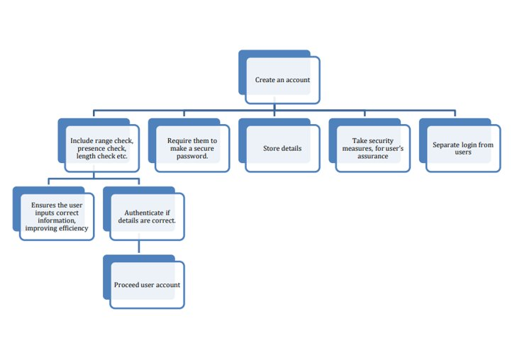

UI Consideration
- Briefly discuss the considerations that you will have to think about when making the user interface thinking about the target audience.
- Talk about colours, images, layout, text, content and more.
Security Considerations
- What security risks will be involved in creating your web-based solution?
- How will you mitigate these potential risks?
- Make sure each one is specific to your particular solution and is not just generic
Legal and Regulatory Guideline Considerations
- What legal guidelines must you consider when creating the web-based solution?
- Be specific about both computing legislation but also industry related legislation that you must follow

